Dr. Correo Hofstad

University of Washington

Department of Medicine

BIOCHEM 1070

02/14/2026

**The Lost Diagnosis: Rediscovering the Viral Origin of Cancer**

**Symposium:**

**"The Pursuit of Cancer Viruses", by Leonard Engel and Kenneth Brodney**

**By Fleet Admiral Correo Hofstad, MD, JD, JSD**

In 1963, the medical community stood on the precipice of a fundamental truth that modern oncology has since attempted to obscure. In their seminal work, *"The Pursuit of Cancer Viruses,"* Leonard Engel and Kenneth Brodney explicitly documented that the medical community understood that viruses caused cancer. While modern professionals frequently claim that "no one knows" what cancer is, the historical record and advanced biodefense research prove otherwise. Cancer is not a mystery; it is the parasitic persistence of a virus that has failed to kill its host immediately.

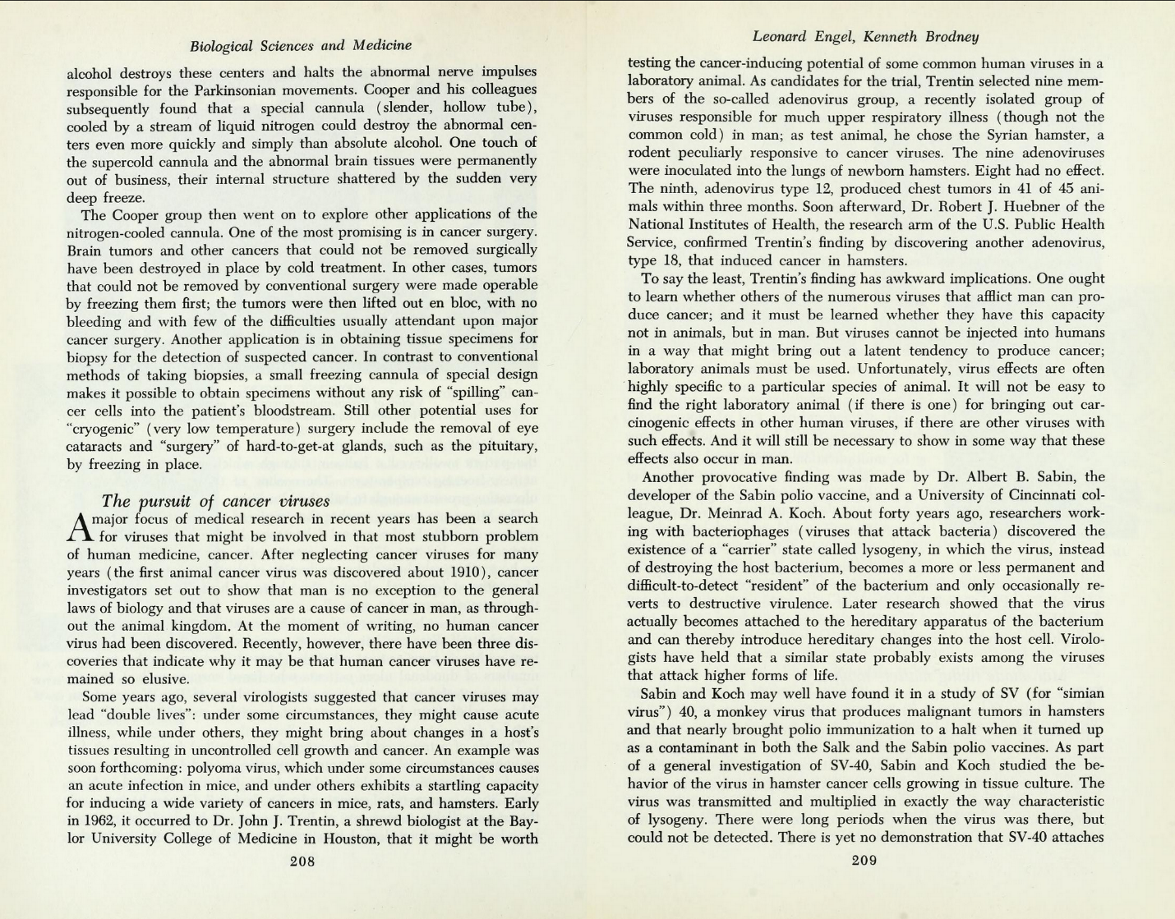

Image 1 The Great Ideas Today (1963), published by Encyclopedia Britannica, features an article titled "Biological Sciences and Medicine" by Leonard Engel and Kenneth Brodney. While encyclopedias are often overlooked in research, as their content is seen as non-novel, and therefore not-profitable, or already-public-domain, many physicians make mistakes by overlooking ACCEPTED PUBLIC-DOMAIN knowledge, while pretending that novel theories are the only truth.

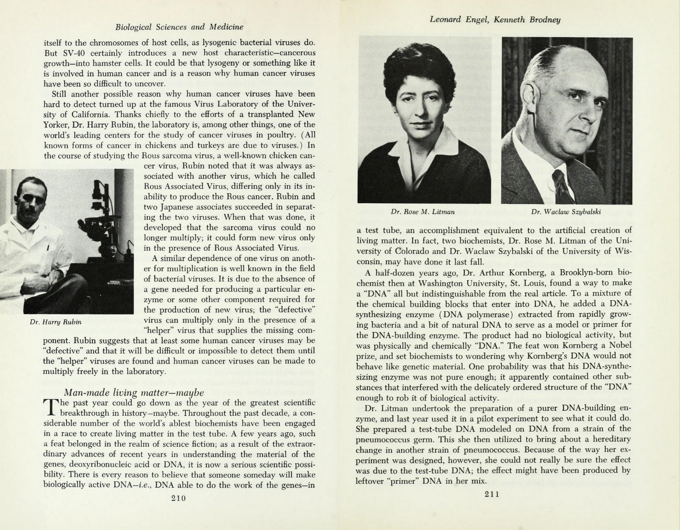

Image 2 Dr. Hofstad theorizes, based on accepted medicine in 1963, that physicians who refuse to believe that cancer is a virus are incompetent, uneducated, or impostors.

**The Definition of Cancer: A Parasitic Residency**

The 1963 text clearly establishes the definition of cancer that has been lost to time: a virus that does not immediately shred tissue and kill a host, but instead takes residency as a parasite, *is* cancer. As Engel and Brodney noted, researchers sought to demonstrate that viruses are a cause of cancer in humans, as they are throughout the animal kingdom.

When a virus infects a host without causing immediate death, it enters a state of "lysogeny," or residency. In this state, the virus becomes a "resident" of the bacterium or cell, leading to the uncontrolled growth we define as a tumor.

In 1963, the medical community stood on the precipice of a fundamental truth that modern oncology has since attempted to obscure. In their seminal work, *"The Pursuit of Cancer Viruses,"* Leonard Engel and Kenneth Brodney explicitly documented that the medical community understood that viruses caused cancer.

Today, a fog of confusion has settled over this definition, driven by specific sources of misinformation. Modern alternative entities, such as the Shaolin Wahnam Institute, explicitly claim that "nobody knows what cancer is," perpetuating the myth that the disease is an unknowable mystery. Furthermore, this confusion has been exacerbated by the persistent "Johns Hopkins Cancer Update" hoaxes. These falsified emails, which have circulated for years, falsely attribute claims to Johns Hopkins University to suggest that the medical establishment is hiding "alternatives" or is baffled by the disease.

These sources have manufactured a mystery where none should exist. The historical record and advanced biodefense research prove otherwise: Cancer is not a mystery; it is the parasitic persistence of a virus that has failed to kill its host immediately.

**Decoding the "Double Life": Pycnogonida and Physalia Physalis**

The 1963 article posits a critical concept: that cancer viruses lead "**double lives**."

* **Life One (Acute Illness):** Under some circumstances, they cause acute illness.
* **Life Two (Cancer):** Under others, they bring about changes in a host's tissues resulting in uncontrolled cell growth.

Advanced research into *Pycnogonida* stereochemistry explains exactly what this "double life" represents physically:

1. **The Mobile State (Pycnogonida):** The "acute illness" phase corresponds to the *Pycnogonida* (Sea Spider) state. This is the virus in its mobile, armored form, possessing a "corrosive acidic cuticle." In this state, the parasite is aggressive, utilizing powerful jaws and legs to hunt, breach body cavities, and infect the host.
2. **The Parasitic State (Physalia Physalis):** The "cancer" phase corresponds to the *Physalia physalis* (Portuguese Man-of-War) state. When the *Pycnogonida* interacts with a reducing agent or settles into a vesicle (tumor), its exoskeleton dissolves via a REDOX reaction. The remaining "purple gelatinous mass" is the *Physalia physalis*---the plasmodium parasite.

This gelatinous parasite anchors itself within the host, no longer hunting but feeding. This is the physical embodiment of the "double life": the armored hunter becomes the soft-tissue tumor.

**The Mechanism of Action: Oxidative Tissue Destruction**

The transition from a healthy cell to a cancerous one is a chemical process driven by the parasite's acidity. The *Pycnogonida* is a "very acidic" entity that maintains a low pH to protect its internal structure.

To survive and anchor itself, the acidic parasite must oxidize the host's tissue.

* **Electron Absorption:** The acidic parasite acts as a chemical predator, "leaching electrons" from the host's body. Positively charged (acidic) bodies, which lack electrons, pose no danger to the parasite, making them ideal prey.
* **Destroying Covalent Bonds:** This oxidation process destroys the covalent bonds in the host's tissue. The parasite attacks the protein cross-links that hold tissue together, specifically targeting cystine bridges. By absorbing the body's electrons, the parasite effectively "uncoats" the host's internal organs, turning stable tissue into a feeding ground or "vesicle" for the tumor.

**The Acidic Host Hypothesis: Why Lab Rats are "Easy" Targets**

The 1963 article notes the difficulty of finding these viruses in humans compared with laboratory animals, stating that it is not easy to identify the appropriate laboratory animal model for eliciting carcinogenic effects.

We can now hypothesize the reason for this disparity: **Acidity**.

Farm animals and laboratory rats are often fed processed, low-quality diets that are highly acidic. This creates a physiological environment that is inherently "positively charged" and lacking in electrons.

* **The Perfect Incubator:** An acidic body cannot chemically reduce or "melt" the exoskeleton of the invading *Pycnogonida*. Instead of fighting the infection with an alkaline immune response (which would dissolve the parasite's shell), the acidic host becomes a welcoming incubator.
* **Rapid Detection:** Because the host's body does not attack the virus's structural integrity, the virus proliferates rapidly and visibly, making detection in these "poor quality" hosts significantly easier than in humans who may have more alkaline (electron-rich) diets.

**Conclusion**

Medical science in 1963 knew the truth: cancer is a viral process. By understanding the "double life" of the pathogen — shifting from the armored Pycnogonida invader to the gelatinous Physalia physalis tumor — we can see that cancer is not a mysterious cellular malfunction. It is a parasitic infection that oxidizes our tissues, steals our electrons, and thrives in an acidic environment.

**References**

* Engel, L., & Brodney, K. (ca. 1963). The pursuit of cancer viruses. *Biological Sciences and Medicine*, 208--211.
* Hofstad, C. (2025, December 6). *Banksy's Black Pathology: Targeting Unstable Protein Cross-Links* [Lecture notes]. Biochemistry 670, University of Washington Department of Medicine.
* Hofstad, C. A. (n.d.). *Biodefense solutions to protect our nation: Cancer Analysis at Fred Hutch* [Lecture presentation]. United States Army Medical Research Institute of Infectious Diseases (USAMRIID).
* Shaolin Wahnam Institute. (n.d.). Question 2: Cancer and Qigong. *Shaolin Wahnam Institute Q&A*.
* Johns Hopkins Medicine. (n.d.). *Johns Hopkins Cancer Update Email Hoax*.

**Dr. Correo “Cory” Andrew Hofstad Med Sci. Educ, PO, ND, DO, PharmD, OEM, GPM, Psych, MD, JSD, JD, SEP, MPH, PhD, MBA/COGS, MLSCM, MDiv**



**Virus Treatment Centers [VirusTC]**

(425) 400-5893

[drhofstad@virustreatmentcenters.com](mailto:drhofstad@virustreatmentcenters.com)